**Christmas dedication 2024 ‘Bringing light’**

**Background information and extra suggestions**

**About light and dark**

During the preparations we talked about what occupies us writers at this moment. For example, the powerlessness you may feel with everything that is going on in the world: war, violence and climate change. But also the business of everyday life and loneliness. The words ‘hope’ and ‘light in the dark’ made a pass. We wondered: how do you keep the fire of love burning in these times with so much darkness? What perspective do we choose?

We chose to use the image of gathering around the fire. If you ever stood around a fire, you know that the fireside is light and warm. But at the back it is dark and your back gets cold. It is important to keep the fire burning.

At that fire, we can tell each other stories. It is what people have been doing for ages. This is how we keep hope alive, feel connection and let the light shine in the dark. Just like that special child that was born two thousand years ago.

Several themes arise in the Christmas dedication. We kept looking for contrast: light in the darkness. Looking for quiet – in the bustling of the day. Remaining hopeful – opposite fear. Looking for connection – opposite polarisation and loneliness. Getting into action – opposite remaining passive from a feeling of powerlessness.

The Christmas dedication is written as a story, not as a play. Of course, the text can easily be read by different people.

If you want to, you can choose other songs or add your own stories. Make sure that it doesn’t become too long.

**Song *Silent Night***

As there is no translation of the new song text for *Still is the night*, we revert to the ‘old’ English version of *Silent Night*. But we will use the version that once was arranged by br. Westerveld many years ago. It starts with an instrumental *O Come All Ye Faithful* to move into *Silent Night*.

**Song *Die donker***

This South African song is hymnlike with beautiful full harmonies in an a cappella divisi choral texture. The text, in Afrikaans, is about the darkness of night and yearning for the light of day.

“Because the dark always comes before The Light. A beautiful example of self-distancing, yet coming together for something magical…”

**Visualisation of the campfire**

With this Christmas dedication, a little fire is sort of mandatory!

* You can light a brazier outside: a warm welcome for everyone. Or, afterwards, a good place to talk, reflect and drink hot chocolate.
* Inside you can make a fake woodfire from logs, (orange/red) LED lights and/or orangy-red tissue paper.
* Make a campfire from flowers, perhaps with a fake hearth underneath.

**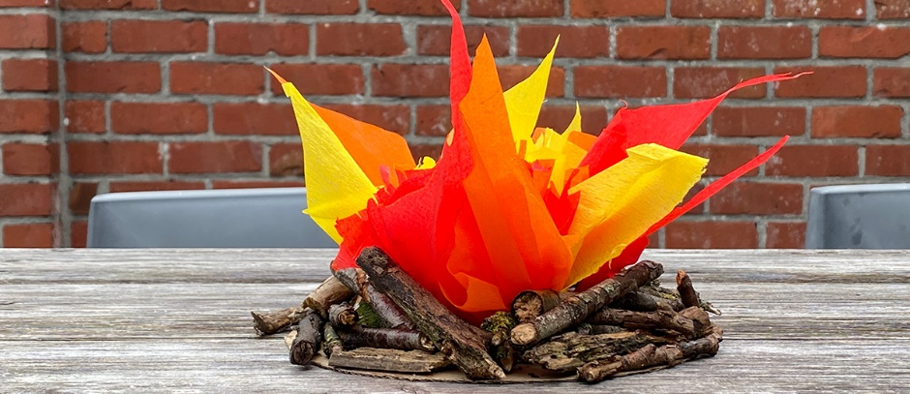

**Extra text from *A Living in Love***

When I sit by the fire, talking to my friends, it makes me think: why do I say so much when I am often unable to put my words into action? My heart answers: When you publicly declare your ideas, you should also try to live by them. Because I think I am what I proclaim, I eventually change into what I say.

Source: *A Living in Love*, 26 May, based on Paolo Coelho, *Warrior of the Light*, 2002. As used in Christmas dedication *Love offers firm ground*, 2011.

**Ritual**

In the celebration of the solstice, the conquering of the light is a central theme. You can make a ritual around it yourself. Make a fire in your hearth or brazier or light a candle. Write down on a slip of paper what, at this moment, hinders you the most in life. Then let it disappear into the fire and say goodbye to that which no longer serves you. Finally, thank yourself for all steps – small and big – you have taken this year. Honour your courage, your force and your determination.